John Kucera

Prof. Mark Muñoz

CMIS 242

23 April 2019

Week 6, Project 3

HOW IT LOOKS:

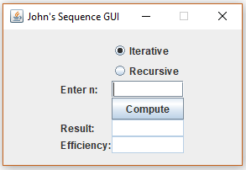

|  |  |  |  |
| --- | --- | --- | --- |
| **Input  (into GUI)** | **Expected Output** | **Actual Output (SCREENSHOTS from Netbeans IDE)** | **Pass?** |
| Compute ssssss | Message Dialog Box: Please enter a valid integer. |  | YES |
| Compute 3.3 | Message Dialog Box: Please enter a valid integer. |  | YES |
| Compute 0 (Iterative) | Result: 0  Efficiency: 0 |  | YES |
| Compute 0 (Recursive) | Result: 0  Efficiency: 1 |  | YES |
| Compute 1 (Iterative) | Result: 1  Efficiency: 0 |  | YES |
| Compute 1 (Recursive) | Result: 1  Efficiency: 1 |  | YES |
| Compute 3  (Iterative) | Result: 5  Efficiency: 2 |  | YES |
| Compute 3  (Recursive) | Result: 5  Efficiency: 5 |  | YES |
| Compute 5  (Iterative) | Result: 29  Efficiency: 4 |  | YES |
| Compute 5  (Recursive) | Result: 29  Efficiency: 15 |  | YES |
| Compute 10  (Iterative) | Result: 2378  Efficiency: 9 |  | YES |
| Compute 10  (Recursive) | Result: 2378  Efficiency: 177 |  | YES |
| Click Close | File created in project/program folder titled “EfficiencyData”. Contains number of loops/recursions for the respective methods from n = 0 to n = 10, stored in neat lines and with commas between values. |  | YES |

EfficiencyData COMPATIBLE WITH EXCEL? **YES.** Here is the result of opening it in Excel:

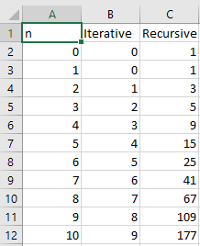

EfficiencyData turned into a line graph in Excel:

This is the graph created by Excel from my EfficiencyData file. The y-axis is number of efficiencies, and the x-axis is value of n. I can tell from this data that iterative loops increase at a steady and slow rate, as n increases, compared to recursive calls. There is only 1 additional loop for each time n increases. However, for the recursive method, the rate of calls increases as n increases. This is because it continuously calls upon itself until a specified stopping point.